HOW TO CONDUCT A
CADET MENTORSHIP MEETING
A quick-reference instruction manual for new Saudia mentors

AUDIENCE | New Saudia cadet mentors
TASK | Lead a structured 30-minute progress meeting
OUTCOME | Guide one measurable cadet action
VERSION | Training draft • July 2026

Table of Contents
1. Purpose, audience, and safety | 2
2. Prepare for the meeting | 2
3. Conduct the meeting | 3
4. Assess, document, and escalate | 4
5. Troubleshooting and quick checklist | 5

Safety and Responsibility at a Glance
WARNING | Never promise selection, employment, a favorable assessment, or special access. Mentorship supports preparation only.

CAUTION | Do not make medical, GACA licensing, legal, or immigration determinations. Refer the cadet to the authorized office.

CONFIDENTIAL | Use approved systems, collect only necessary information, and never place sensitive personal data in informal chat messages.

1. Purpose, Audience, and Scope
This manual helps new Saudia mentors conduct a consistent 30-minute meeting that moves a cadet from a broad concern to one documented next action. Use it with participants in the Saudia Cadet Readiness Mentorship Program. Do not use it as a substitute for recruitment policy, flight instruction, licensing guidance, medical advice, or formal selection feedback.
After following this manual, a mentor should be able to prepare for the meeting, assess progress across four readiness areas, choose one priority action, record the decision, and escalate questions that require an authorized answer.

2. Tools and Materials
- Current recruiter-approved cadet requirements and program reference guide
- Cadet progress dashboard or secure participant file
- Four-domain readiness check (Figure 2)
- One-Action Progress Card or approved meeting-note template
- Calendar invitation, approved video platform, and reliable audio connection
- Internal escalation directory for Pilot Recruitment, Flight Training, HR, data privacy, and program coordination

Before the Meeting
1 | Review the cadet’s record — Ten minutes before the meeting, check the previous action, deadline, evidence submitted, attendance, and unresolved questions. Focus on progress since the last contact rather than rereading the entire history.

2 | Verify your sources — Confirm that any requirement you plan to discuss comes from a current, recruiter-approved source. Check the version date. If the source is unclear or outdated, mark the question for verification instead of improvising.

3 | Prepare one opening question — Use a neutral prompt such as, “What changed since our last meeting?” This invites the cadet to identify progress, barriers, and priorities without turning the conversation into an interrogation.

4 | Protect the meeting space — Use the approved platform, avoid public spaces, close unrelated files, and have the secure note form ready. Do not record the meeting unless the program has approved recording and the participant has provided the required consent.

NOTICE | A mentor should arrive prepared with accurate sources, but the cadet should do most of the explaining and own the final action.

3. Conduct the 30-Minute Meeting
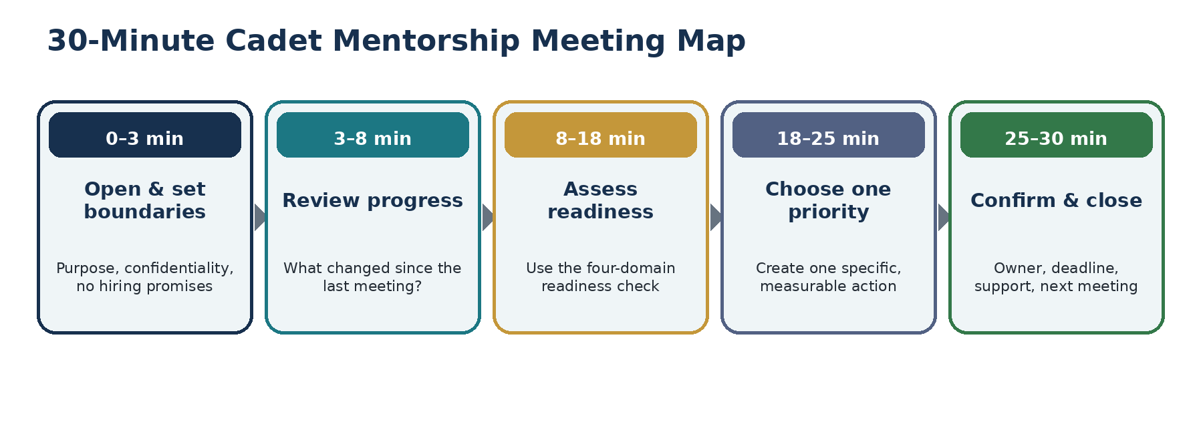
Figure 1. Recommended time allocation for a standard cadet mentorship meeting.
1 | Open the meeting and state the boundary — Welcome the cadet, confirm the available time, and state the purpose: “Today we will review your progress, identify one priority, and agree on a next action.” Remind the cadet that mentorship does not influence hiring or guarantee selection.

2 | Review the previous action — Ask the cadet to explain what was completed, what evidence exists, and what prevented completion if the task is unfinished. Acknowledge verified progress before discussing gaps.

3 | Identify changes and barriers — Ask what has changed in training, education, documentation, scheduling, finances, or personal readiness. Separate facts from assumptions. Do not pressure the cadet to disclose medical or personal information that is not required for the mentoring purpose.

4 | Assess the four readiness domains — Use Figure 2 on the next page. Ask one focused question in each domain, then mark the status as green, amber, or red. A red status does not mean failure; it means the question needs authorized review or immediate attention.

5 | Choose one priority — Select the gap with the greatest effect on the cadet’s next milestone. Avoid assigning several major tasks at once. One completed high-value action is more useful than a long list that the cadet cannot finish.

6 | Build the action card — Define the priority, action, evidence, deadline, and support. Use a specific statement: “By August 8, upload the current English test result and confirm whether a retest is required using the approved requirements page.”

7 | Confirm understanding and close — Ask the cadet to restate the action in their own words. Confirm the owner, deadline, support contact, and next meeting. End with a constructive statement that recognizes effort without guaranteeing an outcome.

WARNING | Do not reveal interview questions, assessment content, internal scoring criteria, or confidential information about other applicants.

4. Assess, Document, and Escalate
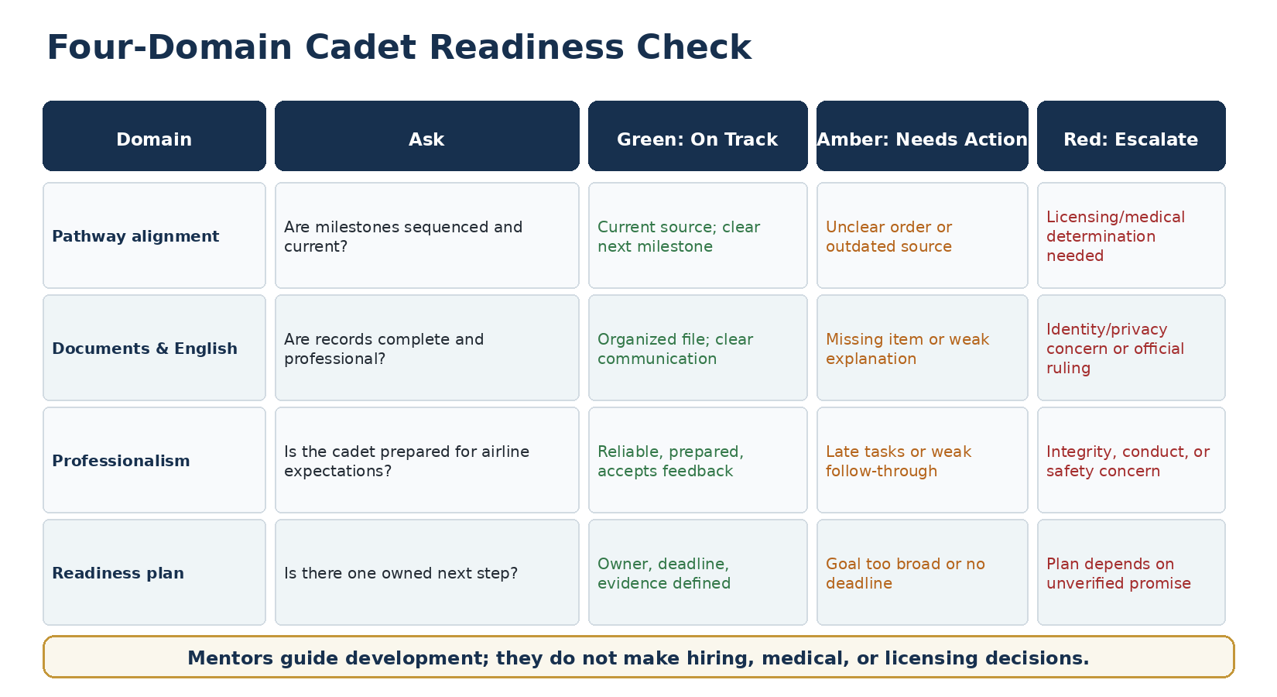
Figure 2. Four-domain readiness check used during Step 4.
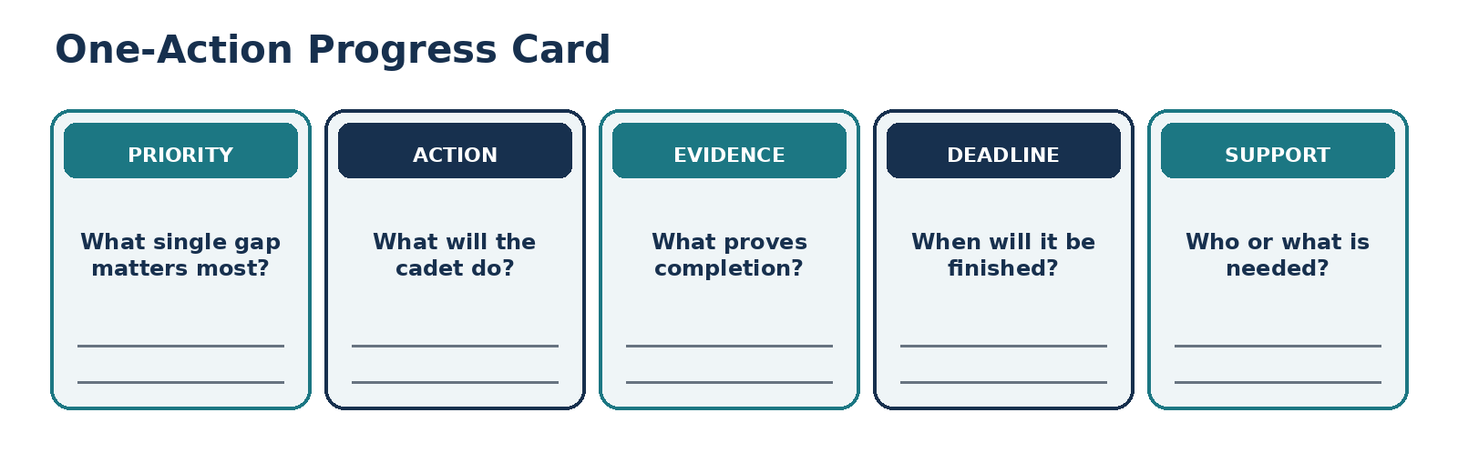
Figure 3. One-Action Progress Card used during Step 6.

Record the Meeting Within 24 Hours
- Date, duration, attendance, and meeting channel
- Previous action and whether evidence was completed
- Green, amber, or red status for each readiness domain
- One agreed priority, action, evidence, deadline, and support owner
- Questions escalated, approved source used, and follow-up date
- Next meeting date or reason the cadet does not need another meeting yet
Write objective notes. Record observable facts and agreed actions, not personality judgments. For example, write “The document was not uploaded by the deadline” instead of “The cadet is careless.”

Use the Escalation Rule
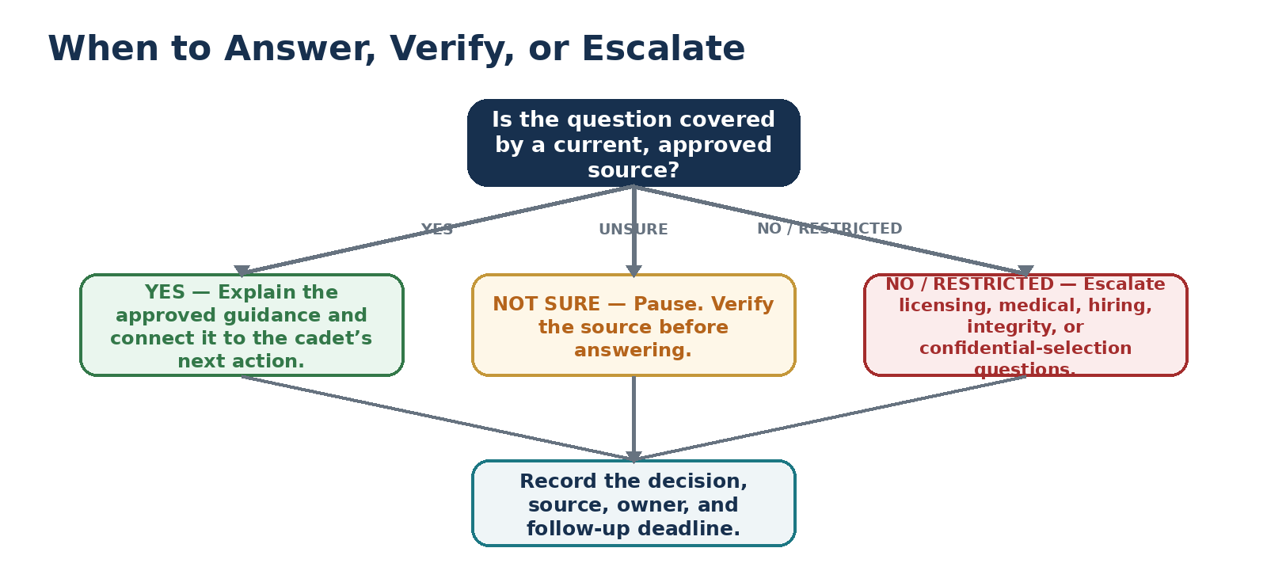
Figure 4. Decision path for answering, verifying, or escalating a cadet question.

5. Troubleshooting
Problem | First response | If that does not work
The cadet made no progress | Ask what blocked the action and reduce the next task to one achievable step. | Escalate repeated barriers to the program coordinator; do not shame or threaten the cadet.
The cadet asks for a hiring guarantee | Restate that mentorship does not affect selection. | Document the boundary and notify the coordinator if the expectation continues.
The cadet asks a licensing or medical question | Pause and identify the authorized GACA, medical, or recruitment contact. | Escalate the exact question; do not interpret rules from memory.
Requirements appear to conflict | Compare version dates and approved sources. | Stop guidance until Pilot Recruitment confirms which source controls.
The cadet misses the meeting | Send one approved rescheduling message and restate the attendance policy. | Follow the program’s missed-contact procedure and record the attempt.
Technology fails | Move to the approved backup channel or reschedule. | Do not move sensitive discussion to a personal messaging account.
The cadet becomes frustrated | Acknowledge the concern, slow the meeting, and return to facts and one next action. | Pause the meeting and contact the coordinator when the issue cannot be handled safely or professionally.

Quick Completion Checklist
- [ ] I used a current, approved source.
- [ ] I stated that mentorship does not guarantee selection.
- [ ] The cadet explained progress and barriers.
- [ ] I checked all four readiness domains.
- [ ] We selected one priority action with evidence and a deadline.
- [ ] I escalated restricted or uncertain questions.
- [ ] I recorded objective notes in the approved system within 24 hours.

Conclusion and Help
A successful mentorship meeting does not solve every issue. It gives the cadet one accurate, achievable step and gives Saudia a consistent record of development needs. When mentors use the same boundaries, readiness check, action card, and escalation process, cadets receive fairer guidance and the program produces useful data for improving applicant preparation.
For process questions, contact the Saudia Cadet Readiness Mentorship Program Coordinator through the approved internal directory.
FINAL CHECK | When accuracy, confidentiality, or authority is uncertain, pause and escalate. A delayed correct answer is safer than an immediate incorrect one.

